INDIA’S AGRICULTURE CROP PRODUCTION ANALYSIS (1997-2021)

INTRODUCTION:

India is the second largest producer of wheat and rice, the world's major food staples. India is currently the world's second largest producer of several dry fruits, agriculture-based textile raw materials, roots and tuber crops, pulses, farmed fish, eggs, coconut, sugarcane and numerous vegetables.

Agriculture has been the backbone of the Indian economy and it will continue to

remain so for a long time. It has to support almost 17 per cent of world population from 2.3 per cent of world geographical area and 4.2 per cent of world’s water resources. The economic reforms, initiated in the country during the early 1990s, have put the economy on a higher growth trajectory. Annual growth rate in GDP has accelerated from below 6 percent during the initial years of reforms to more than 8 percent in recent years. This happened mainly due to rapid growth in non-agriculture sector. The workforce engaged in agriculture between 1980-81 and 2006-07 witnessed a very small decline; from 60.5 percent to 52 percent.

The nation is striving to find ways and means to keep its burgeoning population adequately fed. On the one hand it is facing the problem of declining productivity and on the other, challenges posed by liberalization. In such a scenario, leveraging the available natural resources and existing infrastructure is the only way to make the ends meet. Management of the already built infrastructure in harmony with natural systems is the clarion call of the day. Knowledge of the extent of existing infrastructure and natural resources is one of the most basic pre-requisites to utilize them effectively and in a sustainable manner.

The discipline of agricultural engineering endeavors to develop technologies for enhancing productivity and reducing the cost of cultivation. Traditionally animate power was used for field operations and processing activities. As a result of introduction of mechanical power, agricultural engineering activities have expanded considerably. To sustain the project population of 1.363 billion by 2025 the productivity has to be increased by 100 per cent from the present level by intensification of agriculture. It is estimated that the energy input to agriculture would have to be increased form the present level of 1.3 to 2.4kW/ha.

The achievements of India’s agriculture projects are India's agriculture sector has risen to prominence due to the first Green Revolution. India now possesses the world's giant cow herd and is the world leader in producing milk, lentils, jute, and spices (buffaloes). India is second in growing rice, wheat, cotton, sugarcane, tea, groundnuts, and fruits and vegetables.

India is the world's leading producer of milk, spices, pulses, tea, cashew, and jute and ranks second in the world for producing rice, wheat, oilseeds, fruits, vegetables, sugarcane, and cotton. The growth rate for agriculture and related activities was 3.9 per cent in 2021.

PROBLEM DEFINITION:

EMAPTHY MAP:

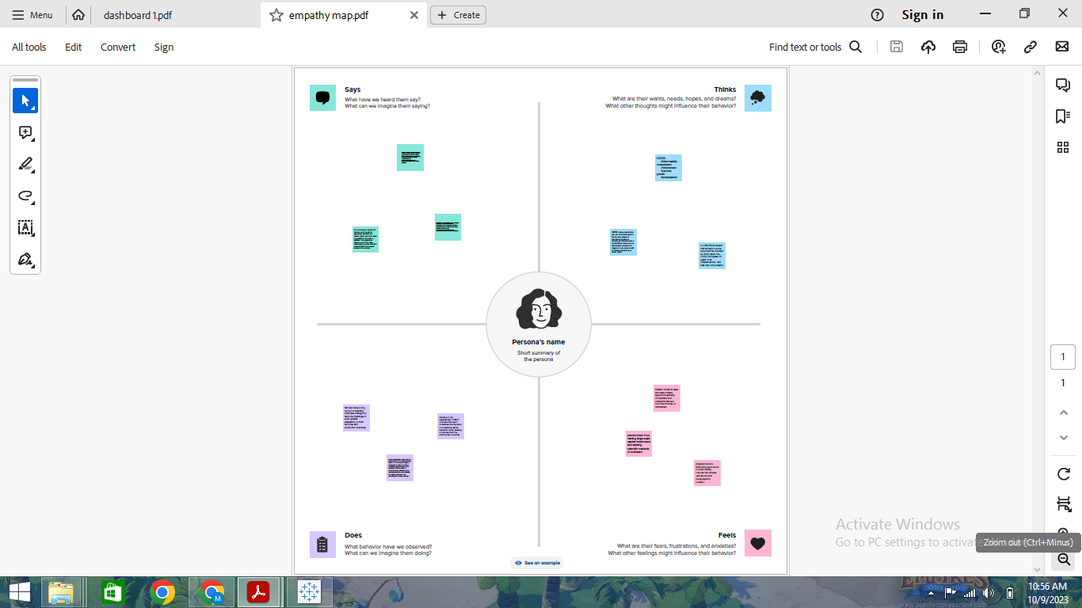

BRAINSTORM:

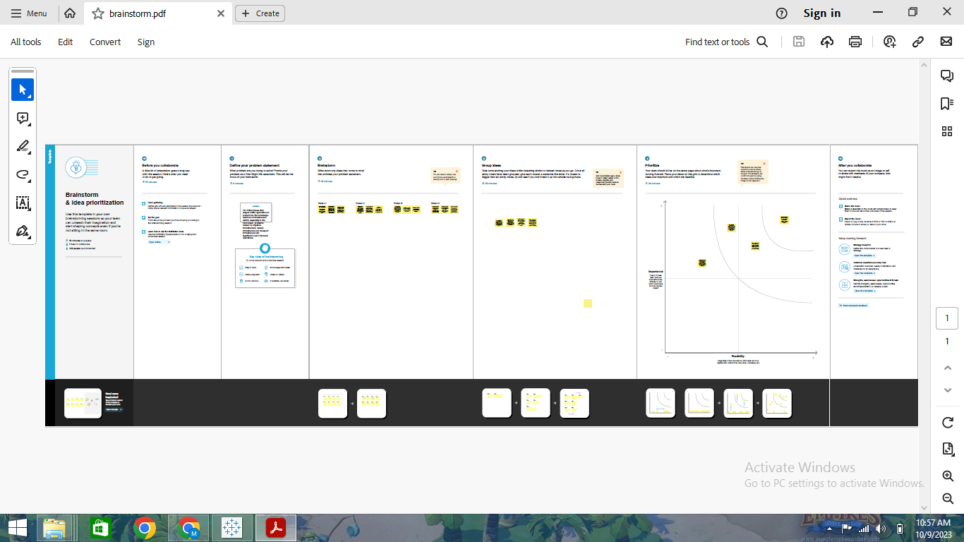

RESULT:

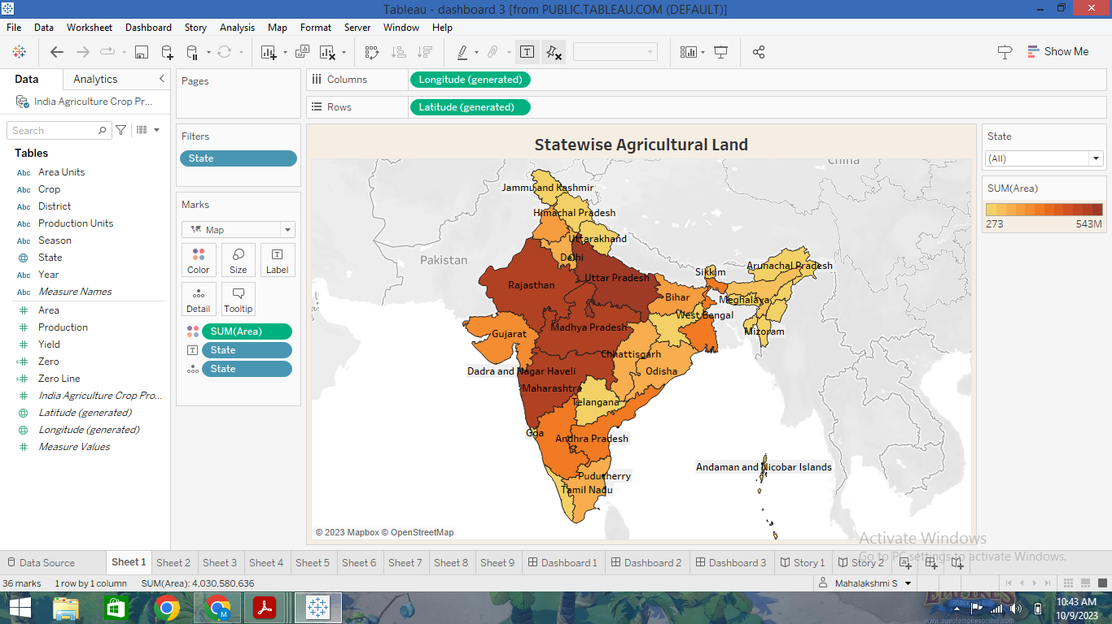

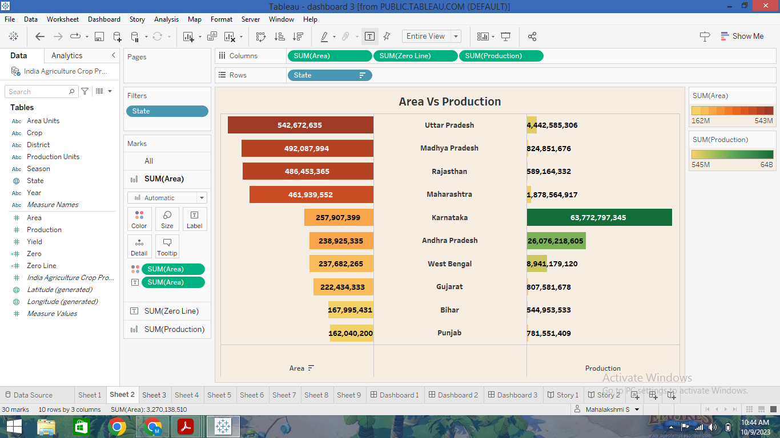

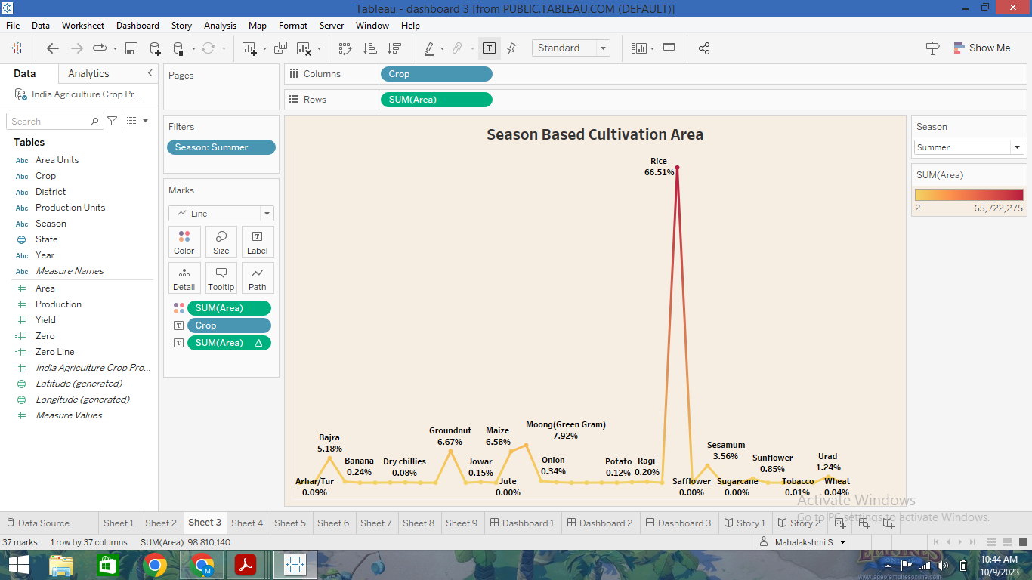

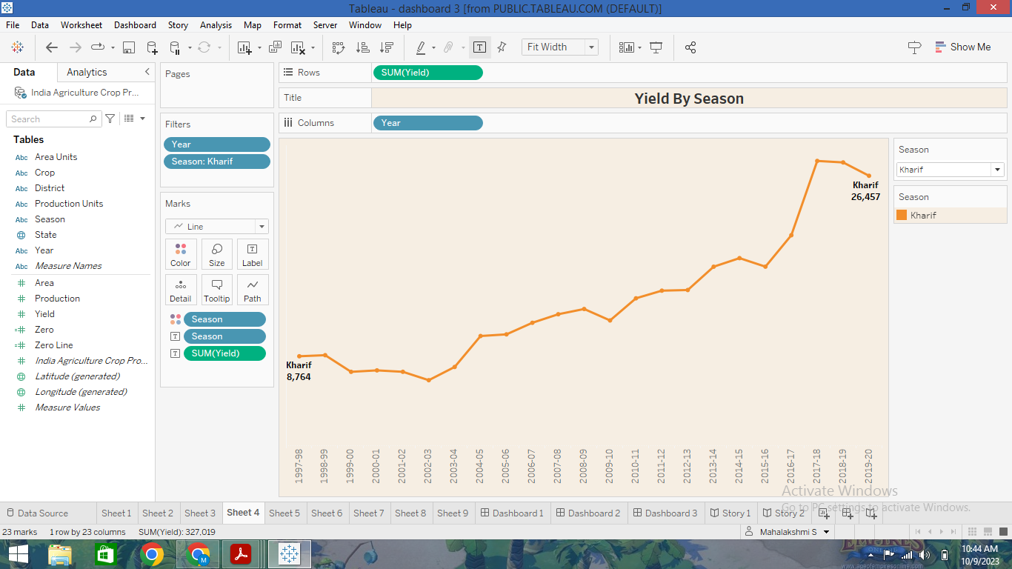

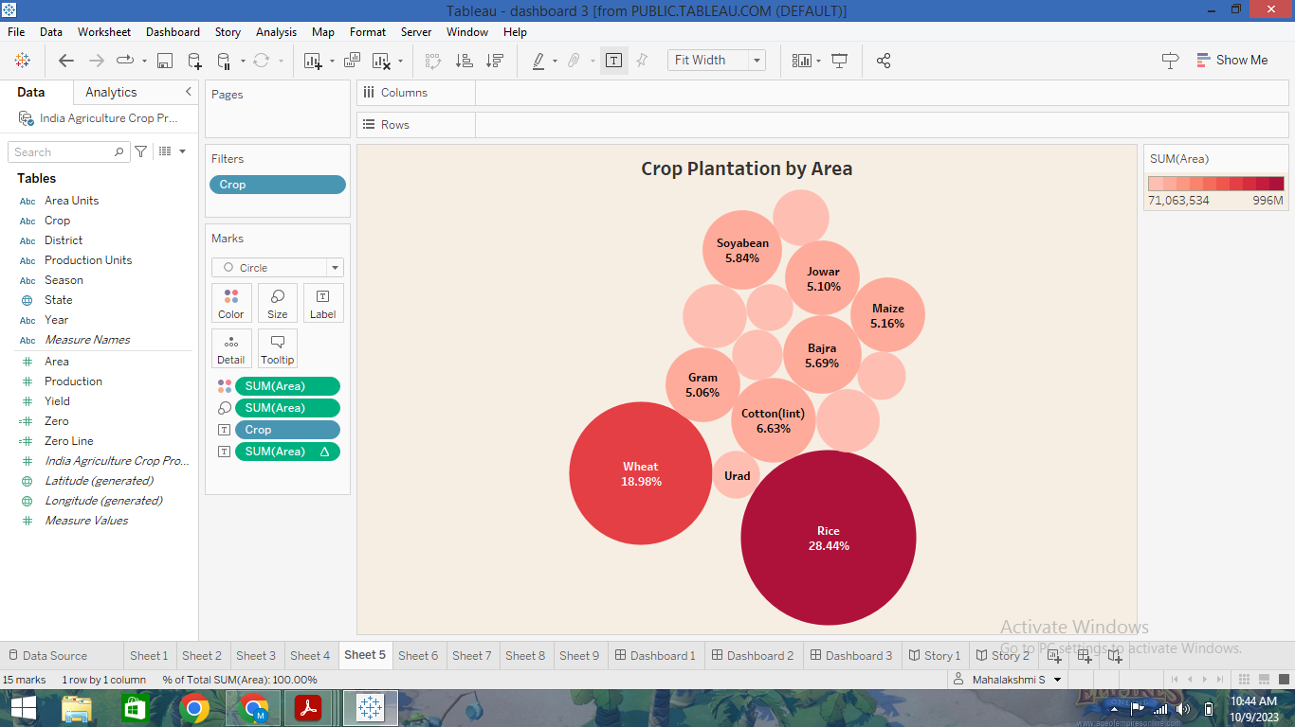

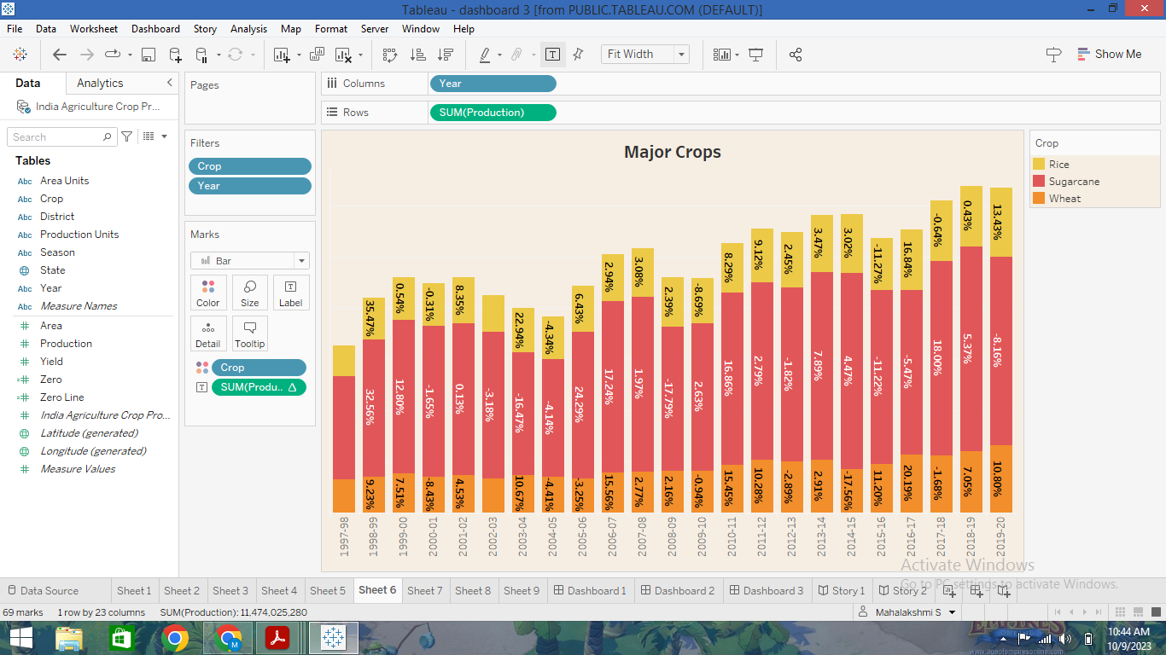

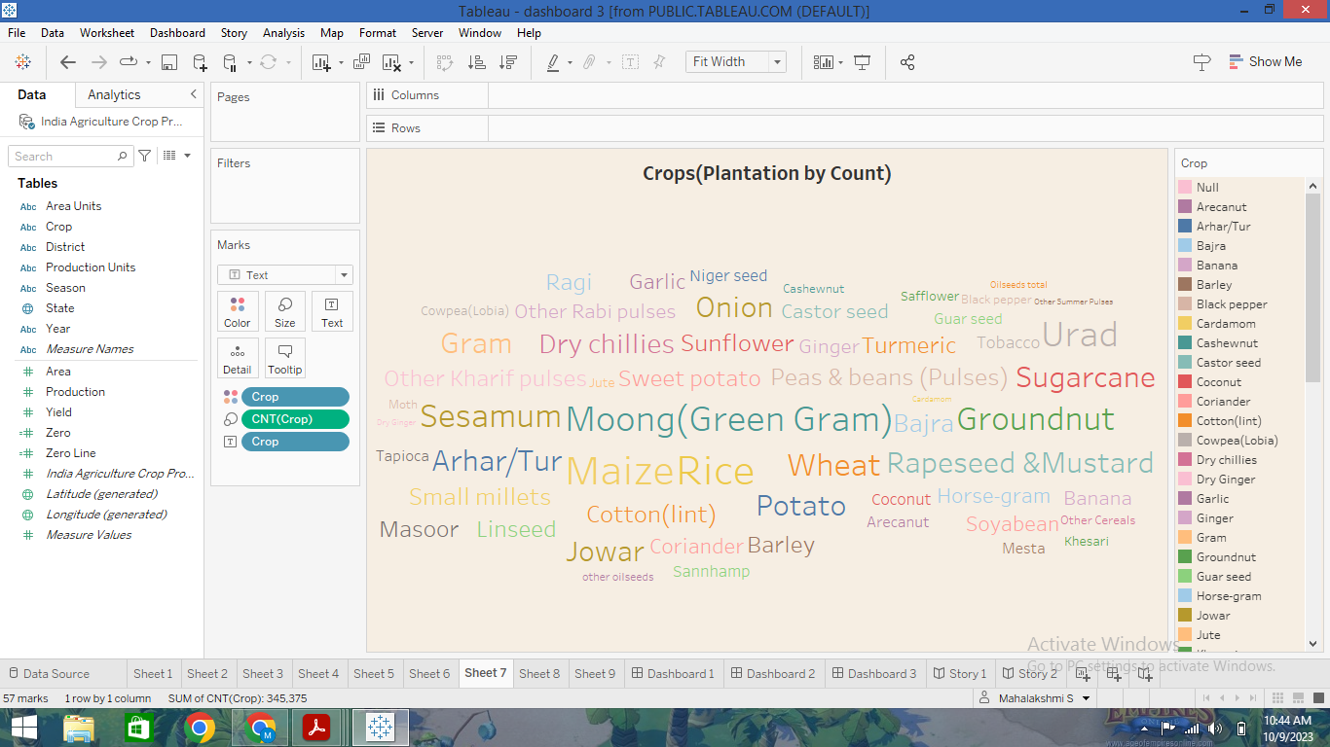

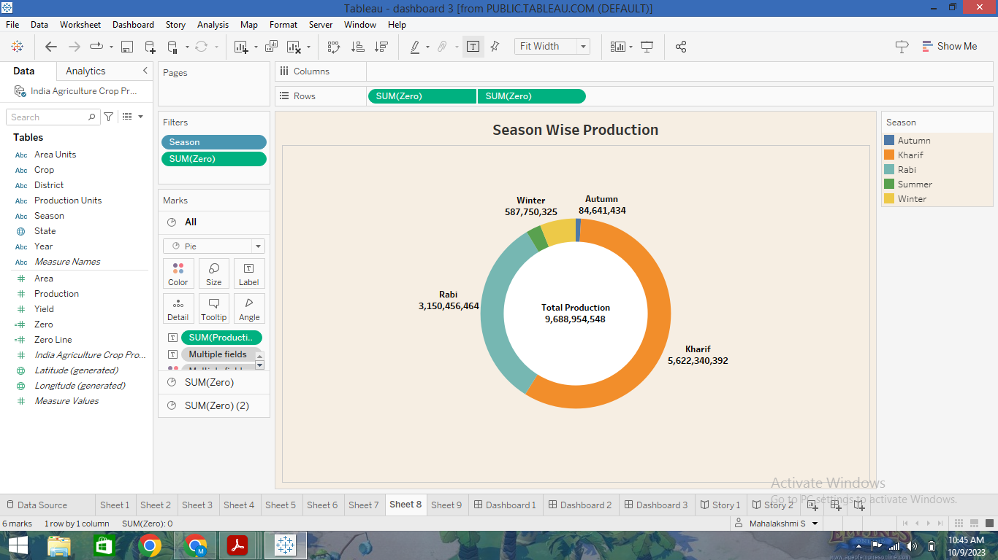

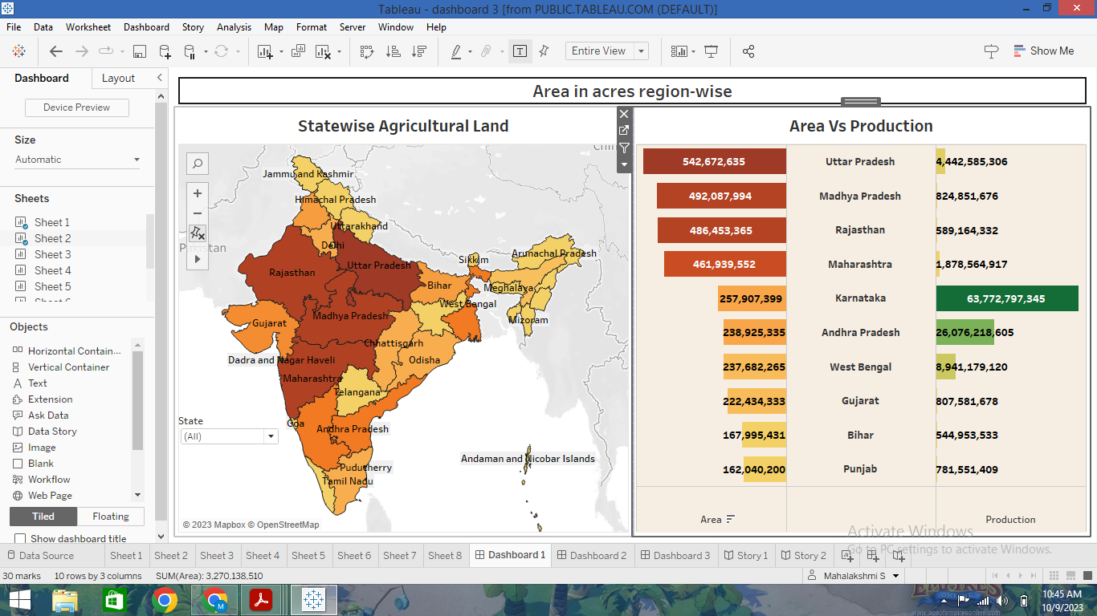

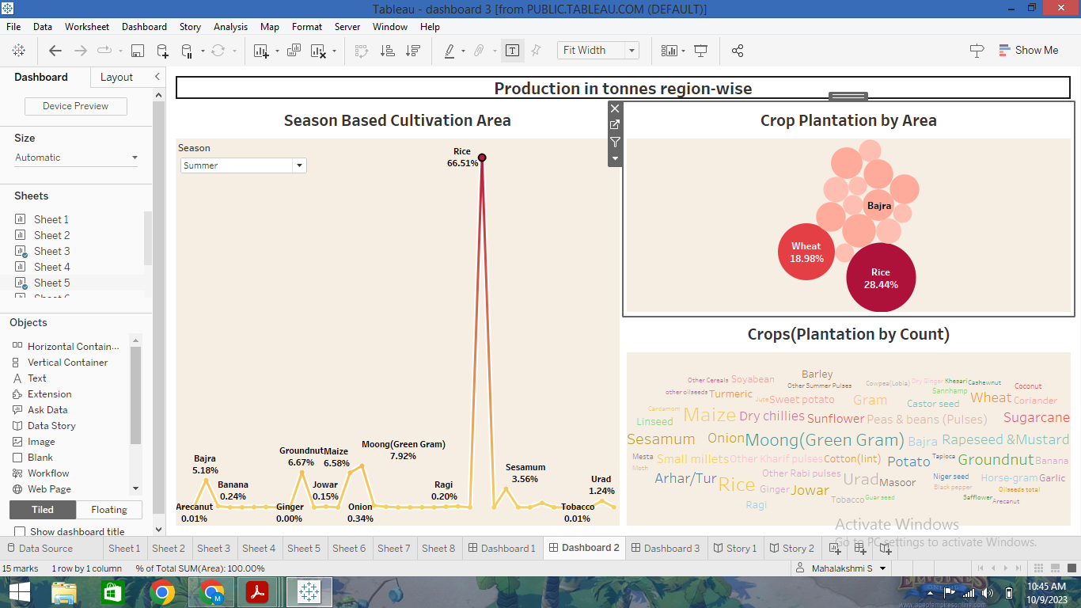

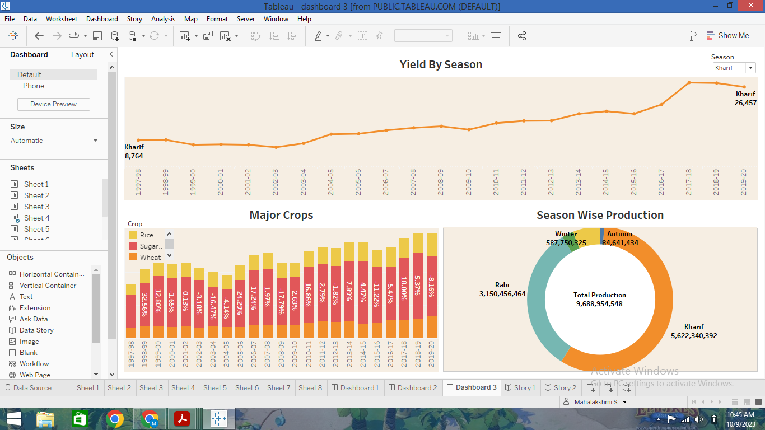

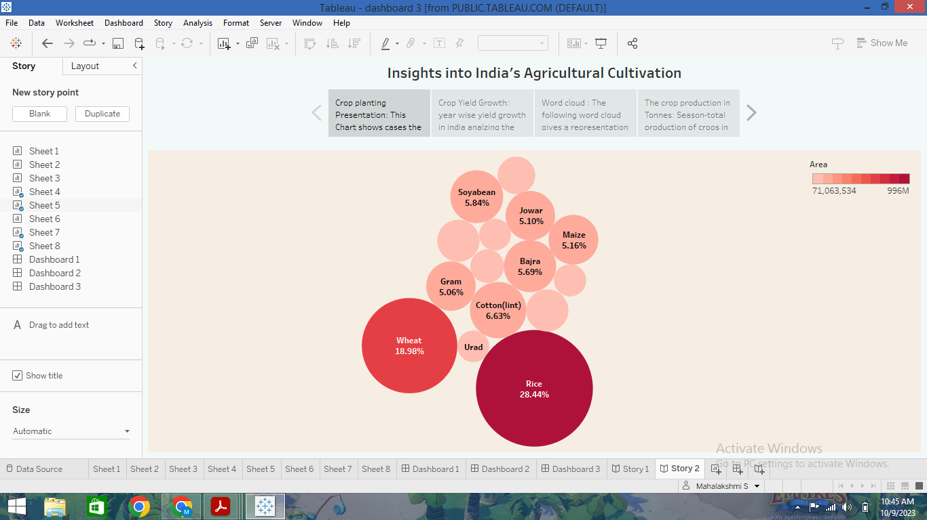

GROWTH OF INDIA’S AGRICULURE:

The agriculture sector has experienced buoyant growth in the past two years. The sector, which is the largest employer of workforce, accounted for a sizeable 18.8 per cent (2021- 22) in Gross Value Added (GVA) of the country registering a growth of 3.6 per cent in 2020-21. Crop output comprises sales, changes in stock levels, and crop products used as animal feedstuffs, or for processing and own final use by the producers.

ADVANTAGES:

1.There is over all increase in yield of crops mainly due to maintaining physical- chemical properties of soil. Soil fertility is restored by fixing atmospheric nitrogen, encouraging microbial activity (more organic matter) and protecting soil from erosion, salinity and acidity.

2. It helps in controlling insects, pests and soil borne diseases. It also controls weeds. E.g. repeated wheat culture (growing) increases wild oats and phallaris infestation. Similarly growing berseem continuously encourages chicory (kasani) infestation, but an alternate cropping of berseem and wheat helps in controlling kasani as well as oats and phallaris.

3. Prevent or limit periods of peak requirements of irrigation water. Crops requiring high irrigation if followed by light irrigation, this will not affect or deteriorate the soil physical condition.

4. It facilitates even distribution of labour. Following crop make proper utilization of all resources and inputs. Family and farm labour, power, equipment and machines are well employed thought the year.

5. Farmers get a better price for his produce due to higher demand in local market. So there is regular flow of income over year.

DISADVANTAGES:

Large-scale, conventional farming focuses on intensive single crop production, mechanization, and depends on fossil fuels, pesticides, antibiotics, and synthetic fertilizers. While this system yields high production levels, it also contributes to climate change, pollutes air and water, and depletes soil fertility.

Erosion of soil by heavy rain, floods, insufficient vegetation cover etc., reduces farm productivity. Inadequate irrigation facilities and poor management of water resources have led to a great decline in agricultural productivity.

It comes with certain environmental concerns: As this type of farming is conducted on a large scale, it can lead to several environmental issues such as deforestation, soil degradation, water pollution, and biodiversity loss.

APPLICATIONS:

The state of Punjab led India's green revolution and earned the distinction of being the country's breadbasket. The initial increase in production was centred on the irrigated areas of the states of Punjab, Haryana and western Uttar Pradesh. Punjab is the most fertile state on earth. It is best to produce wheat, sugarcane, rice, vegetables, and fruits in Punjab. Punjab's other name is the Granary of India and India's breadbasket. Around 93% of the total productive land used to produce food grain.

The plain area's land is highly fertile. These areas usually do not face a scarcity of water because of rivers flowing across them. The soil comprises a vital amount of nutrients.

The agricultural sector is of vital importance for the region. It is undergoing a process of transition to a market economy, with substantial changes in the social, legal, structural, productive and supply set-ups, as is the case with all other sectors of the economy. These changes have been accompanied by a decline in agricultural production for most countries, and have affected also the national seed supply sectors of the region. The region has had to face problems of food insecurity and some countries have needed food aid for IDPs and refugees.

Due to the relatively low demographic pressure projected for the future, the presence of some favourable types of climates and other positive factors, including a very wide formal seed supply sector, it should be possible to overcome problems of food insecurity in the region as a whole, and even to use this region to provide food to other food-deficient regions. Opportunities must therefore be created to reach these results.

FUTURE SCOPE:

NEW TECHNOLOGIES FOR THE AGRICULTURE:

Farmers need to understand the need for new technology. New techniques can help farmers save time that can be used effectively in other activities and professions. The limited use of mechanized farming techniques has hindered the development of a more organized and productive agricultural sector. India is familiar with technology but farmers are unable to adapt due to the cost of new agricultural machines and knowledge. The government will have to take advantage of financial stability and introduce schemes like rental machines or Rashtriya Krishi Vikas Yojana to put new technologies into practice.

ENHANCE HYBRIDIZATION:

Short-term hybrids produce more in less time and thus use less water. Hybrid seeds with intrinsic properties can provide additional resistance to diseases. It saves two to three sprays, reduce chemical use on planets, and reduce the level of chemical residues in soil and water.

DRIP IRRIGATION:

70% of all water use is on agriculture. The agriculture industry needs to focus on improving water quality and addressing water scarcity. This method uses sensors and technology to accurately target water and crop protection targets based on specific geographical needs, pressure from pests and diseases, as well as the needs of the plant life cycle. This water-conscious solution also translates into farmer’s economic savings.

DRONES IN AGRICULTURE:

Imagine a drone that can maneuver crop areas as well as process responses. For example: Identify where grasses are, what type they are, identify pests and diseases, and localize the use of agrochemicals. Around the world, drones are completely changing the whole process of cultivation and harvesting. Industry estimates suggest that the use of drones could increase crop yields by 15 to 20 percent.

AUTOMATIC IN AGRICULTURE:

It is argued at the future of agriculture lies in automation. Modern farming tools and agricultural automation can help smooth the crop production cycle and make it more efficient.

CONCLUSION:

Agriculture has given so much to society. But it has its own pros and cons that we can't overlook. Furthermore, the government is doing his every bit to help in the growth and development of agriculture; still, it needs to do something for the negative impacts of agriculture. Crop plantation agriculture has a long and complex history. It is a vital part of the global food system, and has been an important source of income and employment for many people.